Confusion Matrix Analysis Random Forest:
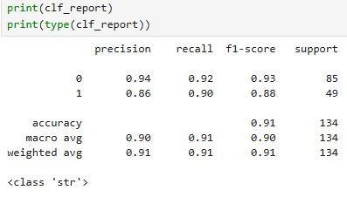
Non – Purchaser Class:
- What is the overall performance of the model - Random Forest (Accuracy) – 91%
it means that model predicts that correct classification of both Purchased & Non Purchased as 91%

- What is the correct model performance of Not purchased (Recall) – 92%
it means that model correctly predicts that customer will not purchase 92% from the total non-purchased data set

- When the model predicts that customer will not purchase, how confident is that prediction truly correct?
With a precision of 94 %, it means that when the model says a customer won’t buy, but only a few non-buyers are misclassified.

- What is the model performance of balancing between Non purchasers and false positive (model wrongly predicted it as purchaser but actually Non purchaser)?
With a F1 score of 93% model balance between Correctly predicted Non-purchaser vs Wrongly predicted purchasers, Actually they are Non purchasers.

- How many Non-purchasers in our dataset?
Non-purchaser – 85 (Possibility model lean towards Non-purchaser)

Purchaser Class:
- What is the overall performance of the model - Random Forest (Accuracy) – 91%
it means that model predicts that correct classification of both Purchased & Non Purchased as 91%

- What is the correct model performance of purchased (Recall) – 91%
it means that model correctly predicts that customer will purchase 91% from the total purchased.

- When the model predicts that customer will purchase, how confident is that prediction truly correct?
With a precision of 86 %, it means that when the model says a customer will buy, but only a few buyers are misclassified.

- What is the model performance of balancing between purchasers and false positive (model wrongly predicted it as Non-purchaser but actually purchaser)?
With a F1 score of 88% model balance between Correctly predicted purchaser vs Wrongly predicted Non-purchasers, Actually they are purchasers.

- How many Purchasers in our dataset?
Purchaser – 49

Macro Vs Weighted Avg:
- If we look at both purchasers and non-purchasers equally, how well does our model perform across the dataset? (Macro Avg)
Macro avg shows around 90% to 91% from both groups.

- How well does the model perform overall, considering that we have more non-purchasers than purchasers?
The weighted average shows we’re about 91% reliable overall, because the model is especially strong at predicting the bigger group of non-purchasers.

